D/T Sarita

Other names
ex Melania
Call sign
LDOY - WQLD
Shipping company A/S Uglands Rederi, GrimstadJ. M. Ugland, Grimstad

Nationality Norway
Shipyard Craig, Taylor Co. Ltd., Stockton on Tees, UK

Build year 1914

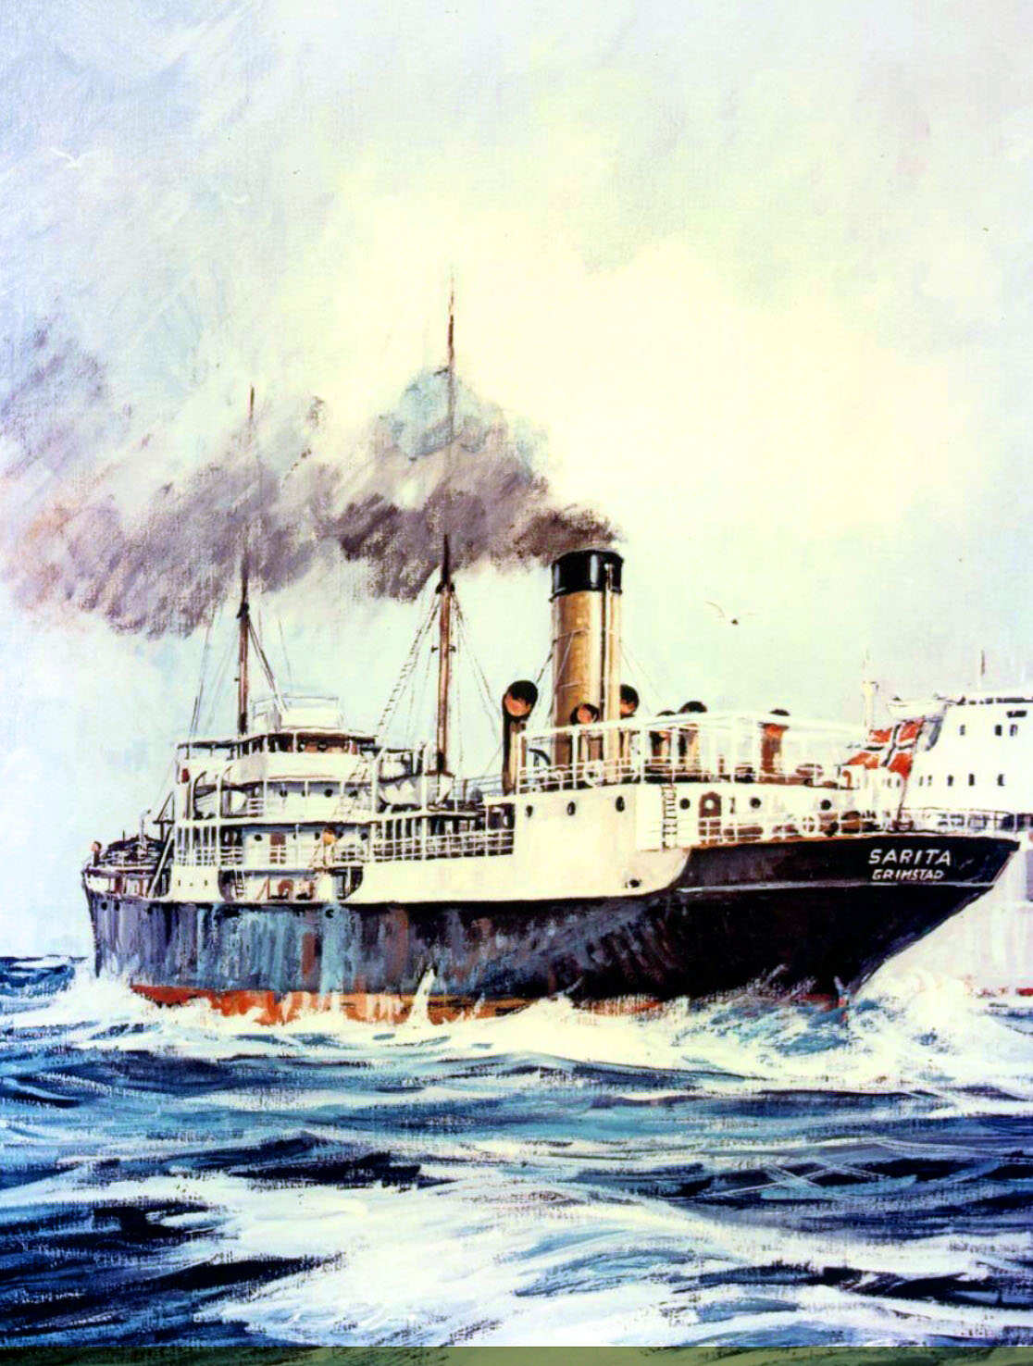
Maritime inquiries 1939 - 1945
- Torpedert
Other
Participant in WW1
Participant in WW2
Torpedoed (14.7.1940)
Tonnage
Gross tonnage:
5.824
Net tonnage:
3.437
Deadweight:
8.300
Engine
Triple 3 cyl.

Speed:
10 knop

Dimensions
Length:
412´0
Beam:
53´3
Draft:
31´1

Sarita 1914
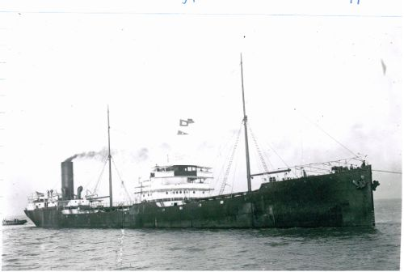
5/1914: Anglo Saxon Petroleum Co. Ltd., London, U.K. - MELANIA
7/1930: A/S Uglands Rederi (J. M. Ugland) Grimstad - D/T SARITA
1936: Skibs A/S Uglands Rederi (J. M. Ugland) Grimstad - D/T SARITA
4/1940: I Nortraship tjeneste.
7/1940: Torpedert 14/7 og synker i pos. N 15.22', W 26.23' av tysk ubåt U-A (Fregattenkapitän Hans Cohausz) 120 n. m. SW av St. Vincent på reise til Trinidad i ballast.
Shipwreck location
Latitude:15.366667 Longitude:-26.466667

